**Problem No: 01**

**Problem Name:** Find y(2) from the following data using Lagrange’s Formula:

x 0 1 3 4 5

y 0 1 81 256 625

**Objective:** To learn Lagrange’s Interpolation Formula.

**Source Code:**

#include <iostream>

using namespace std;

int main()

{

double X[5] = {0, 1, 3, 4, 5};

double fx[5] = {0, 1, 81, 256, 625};

double y = 0, x, x0 = X[0];

int i, j;

cout << "Enter the value of x: ";

cin >> x;

for(i = 0; i < 5; i++)

{

y += ((x - X[(i + 1) % 5]) * (x - X[(i + 2) % 5]) * (x - X[(i + 3) % 5]) * (x - X[(i + 4) % 5]))

/ ((X[i] - X[(i + 1) % 5]) * (X[i] - X[(i + 2) % 5]) * (X[i] - X[(i + 3) % 5]) * (X[i] - X[(i + 4) % 5])) * fx[i];

}

cout << "Result: " << y << endl;

return 0;

}

**Output:**

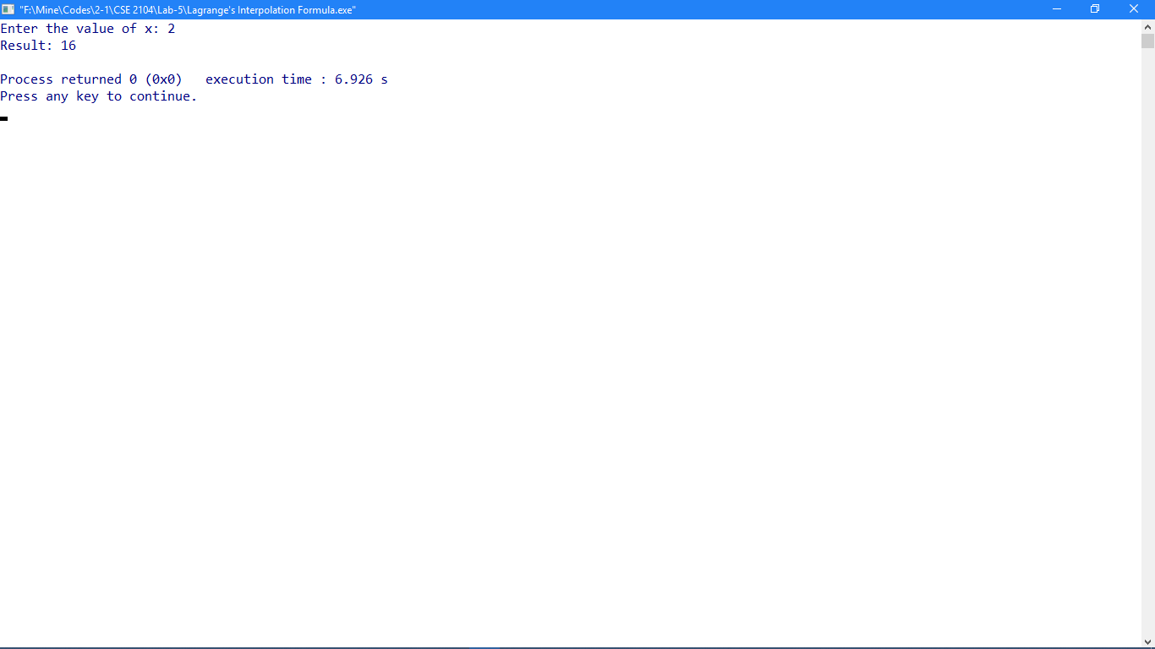

**Problem No: 02**

**Problem Name:** Find the values of a0 and a1 so that Y = a0 + a1x fits the data given in the table:

x 1.00 1.05 1.10 1.15 1.20 1.25 1.30

y 2.7183 2.8577 3.0042 3.1582 3.3201 3.4903 3.6693

**Objective:** To learn how to fit a straight line.

**Source Code:**

#include <iostream>

using namespace std;

int main()

{

double x[5] = {0, 1, 2, 3, 4}, fx[5] = {1.0, 2.9, 4.8, 6.7, 8.6};

double x2[5], xy[5], sumx = 0, sumy = 0, sumx2 = 0, sumxy = 0, a0, a1;

int i, j, n = 5;

for(i = 0; i < 5; i++)

{

x2[i] = x[i] * x[i];

xy[i] = x[i] * fx[i];

sumx += x[i];

sumy += fx[i];

sumx2 += x2[i];

sumxy += xy[i];

}

cout << "x\ty\tx^2\txy\n";

for(i = 0; i < 5; i++)

{

cout << x[i] << "\t" << fx[i] << "\t" << x2[i] << "\t" << xy[i] << "\n";

}

cout << "sum:\n";

cout << sumx << "\t" << sumy << "\t" << sumx2 << "\t" << sumxy << "\n";

cout << "\nEquation:\n";

cout << n << "a0 + " << sumx << "a1 = " << sumy << endl;

cout << sumx << "a0 + " << sumx2 << "a1 = " << sumxy << endl;

a0 = ((sumx * (-1 *sumxy)) - ((-1 *sumy) * sumx2)) / ((n * sumx2) - (sumx * sumx));

a1 = ((sumx * (-1 * sumy)) - ((n * (-1 * sumxy)))) / ((n * sumx2) - (sumx * sumx));

cout << "\na0: " << a0 << endl << "a1: " << a1 << endl;

return 0;

}

**Output:**

